Midterm

Vana Venjimuri

10/12/2019

# Question 1

flights %>%  
 filter(dest %in% c("ATL", "BOS")) %>%  
 filter(origin %in% c("LGA", "JFK", "EWR")) %>%  
 filter(arr_delay <= 30) %>%  
 ggplot(aes(  
 x = origin ,  
 y = arr_delay ,  
 fill = origin,  
 legend = FALSE  
 )) +  
 geom_violin(legend = FALSE) +  
 geom_boxplot(width = 0.1 , fill = "grey") +  
 coord_flip() +  
 facet_grid(rows = vars(dest)) +  
 labs(title = "NYC 2013 Flights within 30 Minutes of Scheduled Arrival",  
 x = "Origin",  
 y = "Arrival Delay")

## Warning: Ignoring unknown parameters: legend

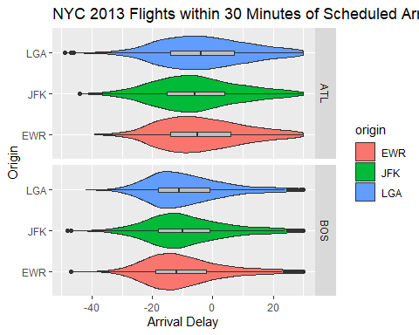

# Question 2

not_cancelled <- flights %>%  
filter(!is.na(dep_delay),!is.na(arr_delay))  
  
not_cancelled %>%  
filter(origin %in% c("LGA", "JFK", "EWR")) %>%  
group_by(origin) %>%  
filter(arr_delay < 0) %>%  
summarize(flight = n(),  
on_time_percentage = mean(arr_delay <= 0, na.rm = TRUE) * 100) %>%  
arrange(desc(on_time_percentage)) %>%  
ggplot(aes(  
x = origin,  
y = on_time_percentage ,  
fill = origin,  
legend = FALSE  
)) +  
geom_bar(stat = "identity", legend = FALSE) +  
labs(title = "Bar Chart (Pareto) of Percentage on Time",  
y = "Percentage")

## Warning: Ignoring unknown parameters: legend

